

**“The Impact of Digital Systems in Manufacturing Environments”**

**Name:** Muhammad Abdullah

**Student Id:** N1365524

**Module Name:** Indiv Ind Res Eng Proj

**Module Code:** ENGG40241

**Supervisor:** Dr Elif Cirkin

(senior Lecturer in Engineering Management)

Contents

Abstract 3

1. Introduction 4

Background 4

Aim 5

Objectives (SMART) 5

Industrial/Research Relevance 6

2. Literature Review 6

3. Methodology 7

4. Planning & Gantt Chart 8

5. Project Risks 9

6. References 10

# Abstract

This research study examines how digital systems are altering contemporary manufacturing processes, including their effects on efficiency, employee engagement, and ecological balance. Technology integration in manufacturing systems, particularly Industrial Internet of Things (IIoT), artificial intellect (AI), and robotics requires critical evaluation of their benefits and challenges for seamless adoption amidst digital transformation. This study applies (MCDM) methodology, integrating literature reviews, case study analyses, and interviews with key informants to evaluate technology application.

The research discovered noteworthy information which demonstrates that digital systems improve productivity in SMEs through predictive maintenance, automation, and data driven optimization, resulting in improved quality and reduced costs. Even if most small and medium enterprises (SMEs) do not face other barriers like high implementation costs, cyber security challenges, and workforce skills, those serious skill gaps tend to present substantial adoption hurdles to almost all SMEs. The research identified an environmental paradox in which the gain in material efficiency is offset by the energy consumed in supporting the digital infrastructure.

The actionable insights conduced through this project are elusive from the tiered adoption framework which aids in enabling the manufacturers to rank technologies in terms of their scalability and cost as well as the workforce readiness. Implementation planning is facilitated through a risk assessment matrix and Gantt chart. The results are the product of scholarly effort as well as the practical world, integrating domains of theoretical research and industry requirements.

This research emphasizes the value of considering all aspects such as technical, organizational, and human elements when devising a digital transformation strategy. The infusion of empirical data with the decision-making frameworks such as SWOT analysis alongside the Analytic Hierarchy Process (AHP) provides a well-rounded plan for the manufacturers who seek to utilize the technologies of Industry 4.0.

# Introduction

Emerging technologies, including the Internet of Things, Artificial Intelligence, and robotics, are changing the analog world of manufacturing into a fully integrated digital one. This advancement is characteristic of Industry 4.0, which improves automation and self-optimizing systems, precise data utilization, along with predictive maintenance to enhance efficacy while simultaneously lowering costs. (kumar 2024)

This project intends to evaluate the impact of implementing digital systems on the manufacturing processes with a primary focus on efficiency, sustainability, and operational agility. The objectives comprise the analysis of significant digital technologies, studying their advantages and disadvantages, and providing recommendations on appropriate actions to address identified gaps. (Sauvage 2021)

The study aims to achieve its objectives through qualitative and quantitative approaches, including literary and case study reviews. It hopes to achieve findings useful to academic research and industry practitioners aiming to refine their strategies guiding the digital transformation agenda. (Boggess 2020)

## Background

The transition to Industry 4.0 has digitized the activities of the manufacturing sector. The Industrial Internet of Things (IIoT) and artificial intelligence (AI), alongside robotics and big data analytics, are transforming production activities with the possibilities of real-time monitoring, predictive maintenance, and autonomous system decision-making. These innovations improve operational efficiency, minimize downtime, and enhance resource consumption, all of which contribute to increased cost savings and better product quality. However, the implementation of digital systems in manufacturing does pose challenges— besides providing benefits, they also have cybersecurity risks, require high initial capital investments, and demand a skilled workforce. (Foo 2024)

The greater need for speed, customization, and sustainability in production fuels the shift towards digital manufacturing. Companies that successfully harness these technologies and integrate them into their operations gain a competitive edge with improved supply chain resilience and reduced environmental impact through energy-efficient processes.

Yet some industries, notably automotive and aerospace, move faster than others due to financial or technological constraints. Grasping the all-encompassing ramifications of digital. (Brook 2023)

## Aim

The objectives of this research project are to address the complex influences of digital systems on contemporary production ecosystems, especially in regard to efficiency, employee relations, and ecological aspects of manufacturing. This study aims to fill the gap regarding how Industrial IoT (IIoT), artificial intelligence (AI), robotics, and big data analytics are disrupting the conventional practices of manufacturing in the light of Industry 4.0 initiatives. It will attempt to measure the quantifiable productivity and cost benefits, at the same time assessing implementation issues like cybersecurity challenges, technological boundary spanners, and workforce readiness. This research seeks to achieve a balanced view documenting the imprints of automation while considering the bounds of small and medium-sized manufacturers by analyzing successful digitalization case studies alongside other incidences of dismal adoption. As a result, the project seeks to develop clear steps constructs that will assist manufacturing firms transform their processes digitally without undermining their market competitiveness. (Folgado et al.

2024)

## Objectives (SMART)

This project will pursue the following SMART objectives to systematically evaluate the impact of digital systems in the multifunctional manufacturing environments. Initially, it will look into critical digital technologies, IoT, AI, Robotics, and Big Data Analytics, by studying their applications, advantages, and limitations in contemporary manufacturing. This will be done through exhaustive literature reviews and case studies of exemplary firms and trying to look for some patterns of success. Subsequently, the project will evaluate operational impacts by analyzing the extent of efficiency improvement and cost saving provided by transformation, through measurable indicators such as digitalized cycle time, defect rates, among others, from available industry data. After that, it will analyze the effects of digital adoption on employment, job responsibilities, skills required, and training through some professional surveys or interviews if possible. Moreover, the study will focus on implementation challenges like cybersecurity issues and the system integration problems along with the financial hindrance and examine these issues using academic literature and industry reports. Lastly, the project will offer suggestions aimed at the defined purpose considering the automation challenges identified in the analysis.

(Herridge 2022)

## Industrial/Research Relevance

Both industry and academia find the incorporation of new digital technologies in manufacturing relevant. From an industrial point of view, this work answers the concern of how manufacturers are understanding and using technologies such as IoT, AI, and robotics for optimizing cost and production competitiveness. Companies globally are moving towards Industry 4.0 which brings with it opportunities and risks. This study attempts to provide solutions to manufacturers who wish to implement fully automated and digital solutions but have to struggle with high initial costs, complexities of integrating other systems, and cross-discipline issues. The findings will be useful in automotive, aerospace, and electronics industries which are manufacturing intensive, and where precision and efficiency are essential. (McKinsey & Company 2022)

This is a case study project under the strategic decision-making puzzle of integrating omni-digital technologies into existing systems. This works adds to the literature on changes brought in the manufacturing industry after adopting digital technologies and embodies gaps in the socio-technical considerations. There is a body of literature around the technical aspects of the Industry 4.0 technologies; however, there is very little comprehensive work looking at their implementation, socio-technical challenges, and sustainability considerations in practice. This study aims to bridge that gap by looking at case studies and drawing the relevant information out of a variety of datasets available.

(dcomisso 2019)

# Literature Review

New technologies are emerging at an extraordinary pace, posing modern opportunities and challenges which require deep consideration. Industrial Revolution 4.0 encompassing advanced robotics, Artificial Intelligence, IoT have sophisticated mechanization, data collection and processing, and decision making at levels never before experienced which is radically transforming production settings. The improvements in operational efficiency provided by these technologies have surpassed expectations with many documented success stories in the domains of production, quality assurance, and maintenance anticipating future needs. Despite these advantages, the shift towards digital manufacturing systems is fraught with significant implementation challenges such as substantial costs, digital security threats, and workforce changes which seem to differ vastly amongst industry segments and organizational scale.

(Immerman 2017)

Groups of larger corporations are digitally transforming and adopting technologies at an accelerated pace compared to their small and medium counterparts. While smaller manufacturers are struggling to keep up because of the limited funds able to be injected into the organization, larger manufacturers have already harnessed competitive advantages from having implemented advanced digital systems alongside other preexisting machinery core to business processes. (Schwab 2016)

Environmental factors add complexity to the adoption of digital technologies in manufacturing. Although digital technologies, such as precision manufacturing, optimize resource usage and material waste, the energy consumption of data-heavy systems and the eco-friendliness of ancillary infrastructure require scrutiny. The approaches towards digital transformation differ across nations because of government policy, industry norms, culture, and other factors. Individual technologies have received significant research attention, yet there is a lack of integrated constructive theories to address the complex interdependence of the factors—technical, social, organizational, and human—of digital adoption. This project will advance current understanding of the impact of manufacturing systems and processes while filling important gaps regarding the impact of digital systems on diverse manufacturing ecosystems. (Javaid et al. 2022)

# Methodology

This research will use a more structured approach with a Multi-Criteria Decision Making

(MCDM) technique that considers all levels of detail related to evaluating digital systems within manufacturing. The main process of is based on primary research mainly done through surveys, questioners and forms made using google or Microsoft services all of them which will be online based. The questions will be close-ended and participants will be obtained through relevant fields.

# Planning & Gantt Chart

For the DSS project, the Gantt chart displays an overall front-loaded timeline. This is illustrated with an early start and a brief literature review that ends by May. This allows the rest of the project to enter the greater problem definition and system design stages through June. By the beginning of July there is an implementation phase which lasts the duration of the month. After that, there is a more concentrated testing and evaluation phase. Writing as well as the report finalization occupy the last week. Such order and structure facilitates an arrangement in which every phase enhances, rather than blends into, the next phase. Because those overlaps are absent, there is smooth control over the project throughout the timeline and transitions are crisp.

***Gantt***

***-***

***chart***

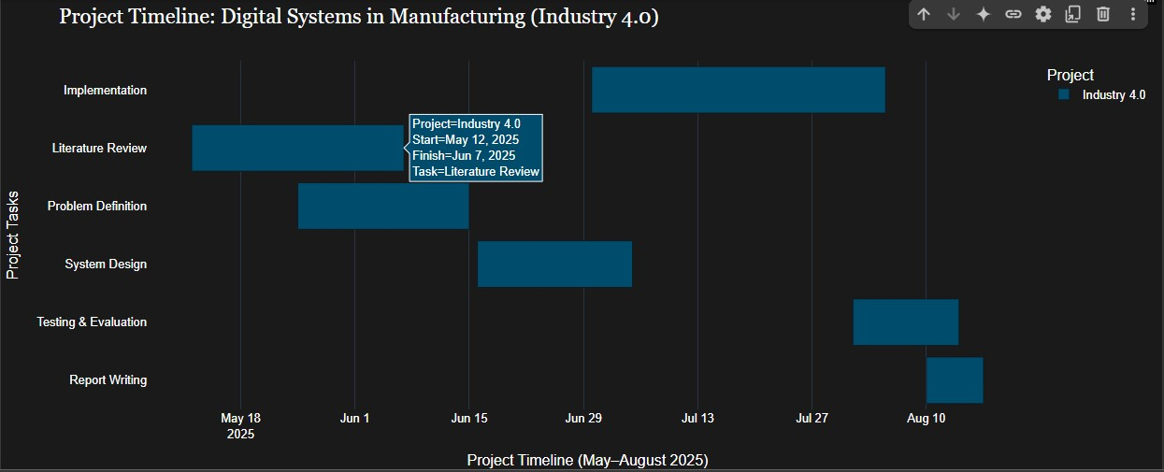

# Project Risks

This project has a few primary risks that could affect its schedule, data integrity, or results. The most prominent risk revolves around data access, as manufacturing companies may withhold sharing proprietary operational data, which could impact the richness of the case study. In order to resolve this issue, alternate sources published within industry reports or documented in academic studies will be sought out in advance. Another risk includes technical constraints, especially if a specialized piece of software, like one used for AHP analysis, does not interface with other systems; this will be reduced by utilizing NTU’s virtual lab resources. (Kuo et al. 2021)

Low response rates to the interviews of workforce participants is another barrier that will be overcome by expanding contacts within several corporations and providing anonymity in the reports. (Sivasankaran. P, Albert 2024)

To allocate time for unforeseen schedule delays during the data analysis phase, buffer time will be added to the Gantt chart in the analysis period (W6 – W9). Also, limited access to premium journals will be overcome with NTU’s library subscriptions and interlibrary loans.

***Risk matrix***

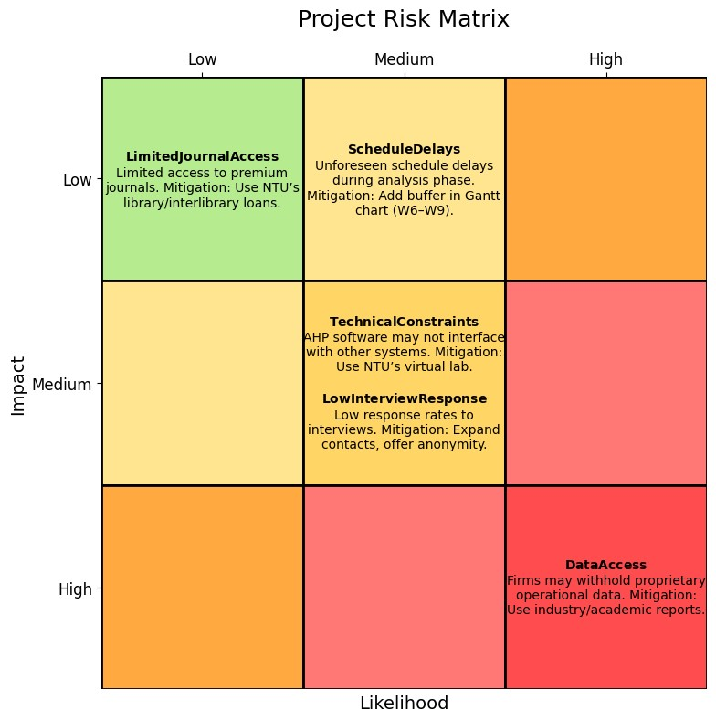

# References

1. Boggess, M., 2020. Industry 4.0: Technologies, Outcomes, and the Future of Manufacturing [online]. *Hitachi Solutions*. Available at: https://global.hitachisolutions.com/blog/industry-4-0-technologies-outcomes-and-the-future-ofmanufacturing/.
2. Brook, J., 2023. How Industry 4.0 Technologies can drive Manufacturing Productivity Growth [online]. *Fourjaw.com*. Available at:

https://fourjaw.com/blog/how-industry-4.0-technologies-can-drive-manufacturingproductivity-growth [Accessed 24 May 2025].

1. dcomisso, 2019. Industry 4.0 challenges and risks [online]. *nibusinessinfo.co.uk*. Available at: https://www.nibusinessinfo.co.uk/content/industry-4.0-challengesand-risks.
2. Folgado, F.J. et al., 2024. Review of Industry 4.0 from the Perspective of

Automation and Supervision Systems: Definitions, Architectures and Recent Trends [online]. *Electronics*, 13(4), p.782. Available at: https://www.mdpi.com/2079-9292/13/4/782.

1. Foo, M., 2024. Real-World Examples of Industry 4.0 Being Used in Manufacturing

[online]. *Abiresearch.com*. Available at: https://www.abiresearch.com/blog/industry-4-0-technologies-examples.

1. Herridge, D., 2022. What are SMART objectives and how do I apply them? [online]. *www.professionalacademy.com*. Available at:

https://www.professionalacademy.com/blogs/what-are-smart-objectives-and-howdo-i-apply-them/.

1. Immerman, G., 2017. Why Industry 4.0 is important [online]. *Machinemetrics.com*. Available at: https://www.machinemetrics.com/blog/why-industry-4-0-is-important.
2. Javaid, M. et al., 2022. Understanding the Adoption of Industry 4.0 Technologies in Improving Environmental Sustainability. *Sustainable Operations and Computers*, 3(1), pp.203–217. https://doi.org/10.1016/j.susoc.2022.01.008.
3. kumar, anil, 2024. What is Industry 4.0 in Manufacturing & Industry 4.0

Technologies [online]. *SG Analytics*. Available at: https://www.sganalytics.com/blog/what-is-industry-4-0-in-manufacturing/ [Accessed 24 May 2025].

1. Kuo, T.-C. et al., 2021. Industry 4.0 enabling manufacturing competitiveness:

Delivery performance improvement based on theory of constraints. *Journal of*

*Manufacturing Systems*, 60, pp.152–161. https://doi.org/10.1016/j.jmsy.2021.05.009.

1. McKinsey & Company, 2022. What Is Industry 4.0 and the Fourth Industrial

Revolution? [online]. *McKinsey & Company*. Available at:

https://www.mckinsey.com/featured-insights/mckinsey-explainers/what-areindustry-4-0-the-fourth-industrial-revolution-and-4ir.

1. Sauvage, M., 2021. Industry 4.0 and digital transformation [online]. *Synox*. Available at: https://www.synox.io/en/industry-4-0/industry-4-0-digitaltechnologies/.
2. Schwab, K., 2016. The Fourth Industrial Revolution: what it means and how to respond [online]. *World Economic Forum*. Available at:

https://www.weforum.org/stories/2016/01/the-fourth-industrial-revolution-what-itmeans-and-how-to-respond/.

1. Sivasankaran. P, Albert, T., 2024. Industry 4.0 Risks and Challenges – Survey [online]. *Journal of Industrial Mechanics*, pp.29–33. Available at: https://matjournals.net/engineering/index.php/JoIM/article/view/721.
2. Taherdoost, H., Madanchian, M., 2023. Multi-Criteria Decision Making (MCDM) Methods and Concepts [online]. *Encyclopedia*, 3(1), pp.77–87. Available at: https://www.mdpi.com/2673-8392/3/1/6.